# **FLT 10–FLT 25**

# **Digital Ultrasonic FLOWMETER**

***For Pipes Under pressure and Open Channel / Rivers \****

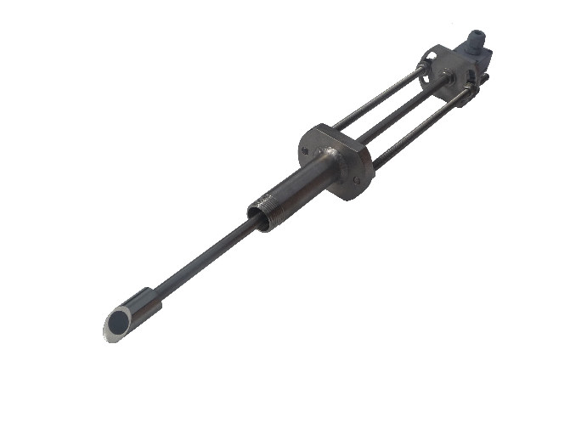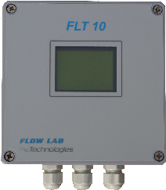

**With standard insertion US sensors FLT25/25 (pair)**

**Digital converter FLT 10**

**- Accurate flow measurement for all kinds of homogeneous fluids under pressure.**

**- For all kind of pressurised pipes material with diameters between 40 and 5,000mm.**

**- Easy installation using 25mm(1”) standard taping systems**

**- Doesn’t request flow interruption for installation.**

**- High accuracy better than 1% and up to 0.2%.**

#### - Not sensitive to LFI (Low Frequency inductions) or poor CP (Cathodic Protection).

* Open channel/surface water Model FLT10-FLT25 “OC” is combining level measurement.

* **Tapping Insertion -25mm (1”)- for the probe FLT 01**

|  |  |  |  |  |  |  |
| --- | --- | --- | --- | --- | --- | --- |
| |  |  |  | | --- | --- | --- | |  |  |  | | Concrete pipe ND 1,200mm | Concrete pipe ND 1,2000mm | *Open Channel “OC” version | |

# Digital Ultrasonic FLOWMETER

**SPECIFICATIONS**

#### The FLT 10- FLT25 ultrasonic flowmeter can measure flow with high accuracy (better than 1%) in all kind of homogeneous fluids (transparent to US waves) and all kind of pipes material.

#### Not sensitive to LFI (Low Frequency inductions) , poor EPR (Earth Potential Rise) and poor CP (Cathodic Protection)

* **Easy installation** using standard under pressure taping systems.
* Doesn’t request **interruption of flow supply**.
* Easy site Configuration using **integrated keyboard** or **dedicated software**.
* **Inbuilt data-logger can store until 100,000** data that can be exported locally or remotely.

#### Better value for money compares with traditional full-bore Electromagnetic Flowmeters

***Version “OC” for Open channels and rivers is also available***

|  |  |
| --- | --- |
| FLT 10 Converter Technical Features **Housing:**  -Cast aluminium with **IP 67 grade.**  -Dimension: 180x180x110 mm  -Weight: 2 kg  **Power supply:**  -External: 220Vac 50/60 Hz _12/24 Vdc  *Optional: -Internal* ***Lithium batteries***  **inputs/Outputs :**  Protected and galvanicaly insulated. Programmable on site with integrated user’s interface.   * 0 or 4-20 mA on 500 Ω * 0-10 V   -Pulses :   * rate configuration : 1L to 100m3 * band width: 100 to 1000 ms   -Flow direction: output open collector  -Communication port: RS 232  -Data storage: 100,000 (internal)  **Display**  -Back-lighted 2 lines LCD display  -Flow in l/s l/h m3/s m3/h, (4 digits)  -2 Totalizers without reset  -1 totalizer with reset (direct way)  -1 totalizer with reset (reverse way)  Performances  -Accuracy: better than 1 % for flow (0, 5 % for velocity)  -Measure range between 0,01 to 15 m/s  easure rang | FLT 25 sensor(s) technical features **Body’s sensors:** -ND ∅ 24 mm-Material: 316 L stainless steel -Standard Operating pressure 30 bars  -Working temperature –20 to + 70° C  -IP 68 grade  -Weight 6 Kg  -Dimensions 500 X 90X 80 mm  Performances -Measure bandwidth: 0.1 m/s to 10 m/s -Accuracy: more than 1% from 0.1m/s to 10 m/s  -Linearity: 0.1 % (automatic zero)  **Installation (1):**  Standard sensors mounting compatible:  -Taping connectors (welding/screwing)  - Saddles (depending on pipes types)  -Standard taping valves: 1’’ minimum   1. *Accessories not included. To be defined prior site installation conditions depending on pipes material, dimension and pressure.*   L (standard) : 500 mm |

**FLT10 -FLT 25 « OC »**

Digital ULTRASONIC FLOWMETER

***For Open Channel and surface water \****

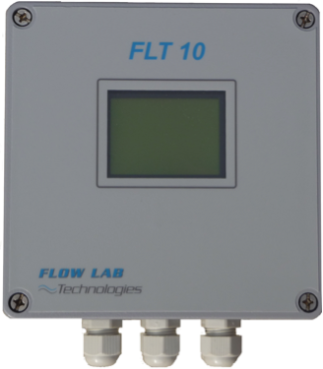

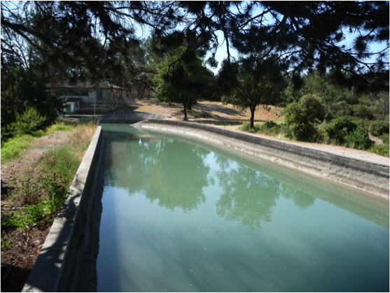

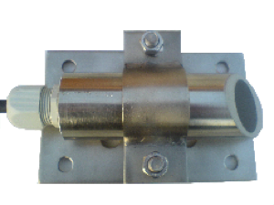

**Digital converter FLT 10 OC**

**Sensor FLT25/35 OC (by pair)**

|  |
| --- |
| **- Accurate Flow measurement of surface water up to 15 m width.**  **- For all kinds of homogeneous fluids (Wastewater, raw / treated water)**  **- Mono chord (pair) or dual chord flow measurement depending on Depth.**  **- Combined level measurement with submersible piezzo or ultrasonic in Air\*\***  **- Accuracy better than 1%**  * Under pressure pipes Model FLT10-FLT25 is also available. ** Depending on site configuration |

|  |  |  |
| --- | --- | --- |
|  |  |  |
| **Rectangular Channel 2,000mm** | **FLT25/35” sensors** | **Ovoid Channel ND 4,000mm** |

**FLT 10 –FLT 25 « OC »**

# Digital Ultrasonic FLOWMETER

**SPECIFICATIONS**

#### The FLT10 OC ultrasonic flowmeter has been designed for measuring bi-directional flow in open channels by combining both flow velocity and level measurement with high accuracy. (water channels, rivers, waste water, )

#### Compatible with all probes/sensors from our range with monochord (1 set of probes) or multi-chords sensors (up to 4 sets) for velocity (m/s) and Ultrasonic (submersible / air) or piezzo-electric for levels (m/bar).

* **Inbuilt data-logger can store until 100,000** data that can be exported locally or remotely.

|  |  |
| --- | --- |
| FLT 10 Converter Technical Features **Housing:**  -Cast aluminium with **IP 67 grade.**  -Dimension: 180x180x110 mm  -Weight: 2 kg  **Power supply:**  -External: 220Vac 50/60 Hz _12/24 Vdc  *Optional: -Internal* ***Lithium batteries***  **inputs/Outputs:**  Protected and galvanically insulated. Programmable on site with integrated user’s interface.   * 0 or 4-20 mA on 500 Ω * 0-10 V   -Pulses :   * Rate configuration : 1L to 100m3 * band width: 100 to 1000 ms   -Flow direction: output open collector  -Communication port: RS 232  -Data storage: 100,000 (internal)  **Display**  -Back-lighted 2 lines LCD display  -Flow in l/s l/h m3/s m3/h, (4 digits)  -2 Totalizers without reset  -1 totalizer with reset (direct way)  -1 totalizer with reset (reverse way)  easure rang | FLT 25 sensor(s) technical features **Body’s sensors:** -ND ∅ 24 mm-Material: 316 L stainless steel -Working temperature –20 to + 70° C  -IP 68 grade  -Weight 2.5 Kg  -Support Dimensions 150 X 100X 2 mm  Performances -Measure bandwidth: 0.1 m/s to 15 m/s -Accuracy: more than 1% from 0.1m/s to 10 m/s  -Linearity: 0.1 % (automatic zero)  **Installation (1):**  **-** SupportSplit/screwed/ on channel wall   1. *Level sensor not included. To be defined prior site installation conditions depending on channel width, depth sizes.*     **Sensor and support picture:** |

**FLT40/FLT01-02**

ELECTROMAGNETIC FLOWMETER

***For pipes Under pressure***

-AC/DC power supply or battery operating (10 years) *

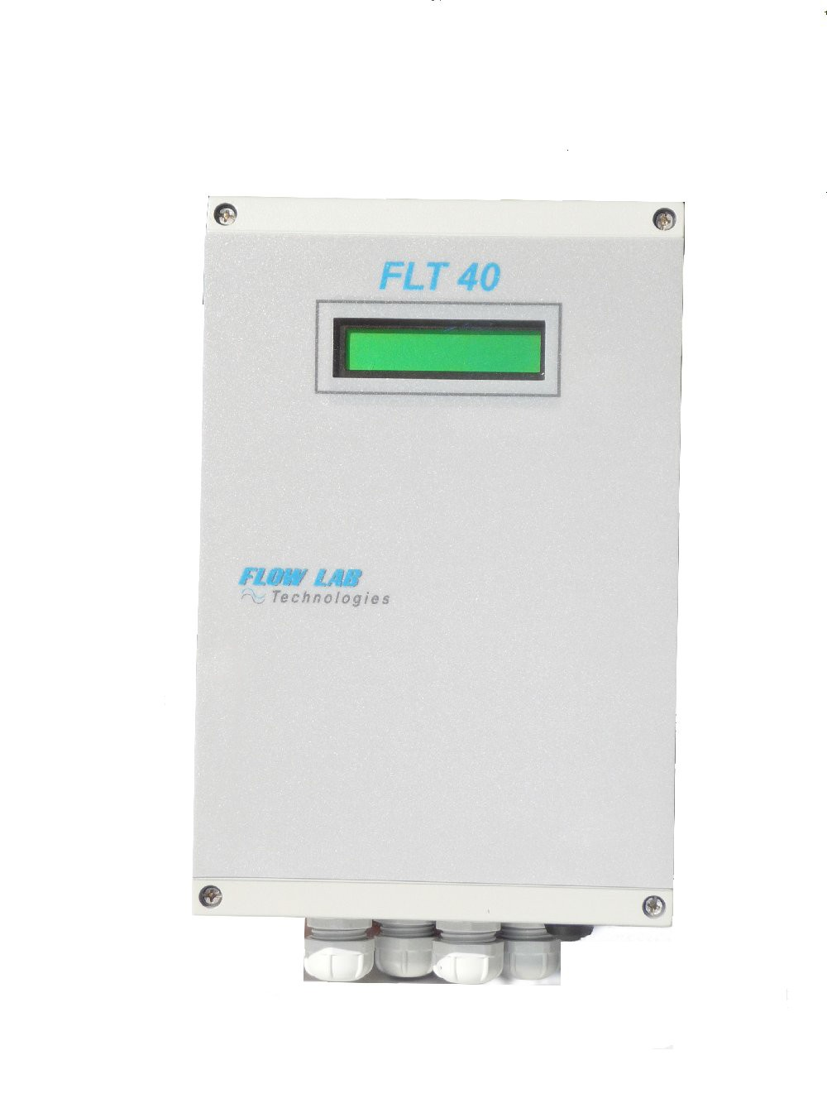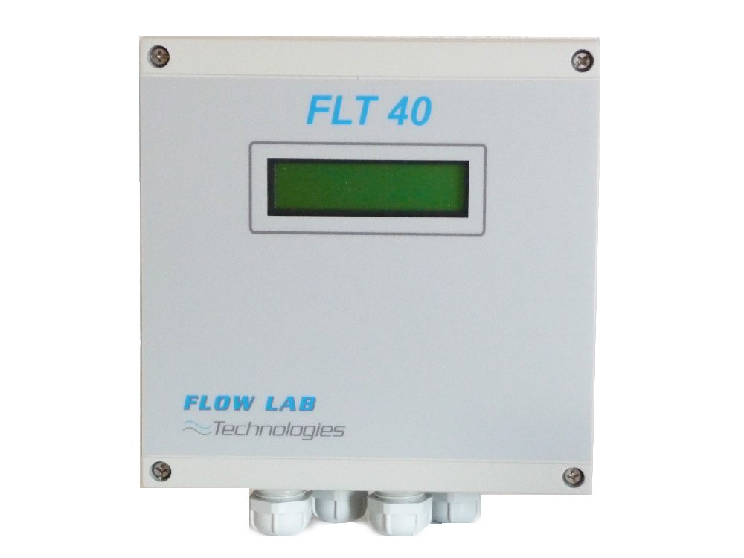

# High accuracy measurement of bi-directional flow for pressurized pipes with

**diameter between 25 mm to 5,000 mm.**

* **All kind of fluids with a conductivity 5 µ Siemens**, clear liquid or with suspended particles.

# Digital micro-processor

* Easy installation.
* Open channels version available and level measurement **(FLT40 CO)**

**Compatible with all EM sensors of our range**

|  |  |
| --- | --- |
|  |  |
| Insertion FLT01- Tapping insertion | Full-bore FLT02 |

# **FLT 40 –FLT 01-FLT 02**

# Digital Electromagnetic FLOWMETER

**SPECIFICATIONS**

The **electromagnetic FLT40** flow meter is a **digital converter** that has been designed for measurement **of all kind of conductive liquids** using insertion or **full-bore probes** from our range (FLT01, FLT02,)

It can operate either with external power supply or **with internal battery** that will ensure autonomy no less than 24 months and up to 120 months depending on site conditions and configuration.

Inbuilt data-logger (minimum 12,000 data) are available for both flow and totalizer recordings.

Technical Features

Converter can be deported or mounted directly on sensors Solid Housing case built in cast aluminum - **IP 67/68 grade**

-Dimension: 160x160x90/120mm

-Weight: 1.5kg

## Power supply:

-External 220Vac 50/60 Hz or 12/24/48 Vdc

-**Lithium batteries: autonomy** from 24 up to 120 months

## Key features

Outputs are protected and galvanically insulated. They are programmable on site using integrated user’s interface.

-Current outputs: 0 or 4-20 mA on 500 Ω(not available for lithium battery powered)

-Pulses rate configuration: 1L to 100 m3

-Pulse band width: 100 to 1000 ms

-Flow direction: output open collector

-Communication port: RS 232 (115,200 Bauds)

-Graphical back-lighted LCD display (2 lines)

-Flow in l/s l/h m3/s m3/h, (4 digits) Bidirectional volume readings and totalizers:

-2 Totalizer without reset

-1 totalizer with reset (direct way)

-1 totalizer with reset (reverse way)

## Displayed parameters available (depending on modes):

-Flow, Volume, Velocity

-Damping

-Full scale adjustment

-Totalizer output, Pulse band width

-Flow direction (bidirectional).

## Key Performances

-Accuracy**: 0, 5 % of the measure between 0,1 and 15 m/s

-Repeatability: 0,2 % on 5 years

-Linearity: 0,1 % (zero automatic)

* up to 10 years Depending on operating condition // **Up to 0, 2 % on special

**FLT 40FH**

DIGITAL ELECTROMAGNETIC FLOWMETER

***For fire hydrants and DMAs\****

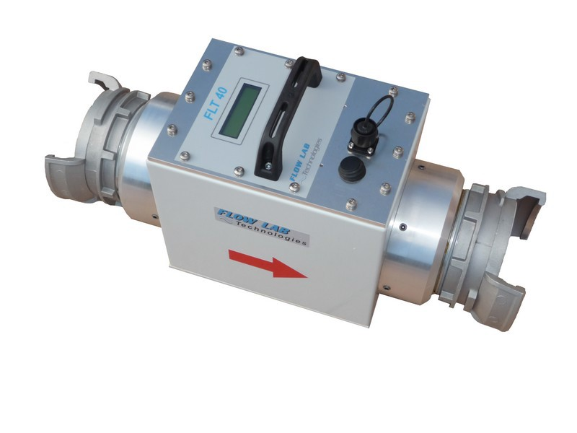

-

* Measurement of **flow and pressure** for diagnostic of **fire-hydrants.**
* Measurement of **flow and pressure** for diagnostic of **DMAs*.**

# Electromagnetic technology

* No pressure loss
* Digital processing of the signal for the flow and pressure
* Recording of the flow & pressure in internal memory (data-logger)
* Nominal Diameter DN100 (*other size and couplings available)
* Autonomy 20 hours minimum

(*) DMAs=District Metering Areas

# **FLT 40 FH**

# FIRE HYDRANT-DMAs FLOWMETER

**SPECIFICATIONS**

Flowmeter **FLT 40FH** has been designed for carrying out efficient and accurate measurement for flow and pressure on fire hydrants.

Its electromagnetic technology ensures a high degree of accuracy in measurements without causing any pressure losses.

Integrated data-Logger is allowing data recording of measurements for flow and pressure with date and time.

The internal batteries can operate for several days.

Parameters configuration and downloading of recorded data are managed using dedicated software and laptop or PC.

## Technical Features

* Metallic IP 68 none -corrosive case box Dimension: 200x200x500
* Weight 11kg
* Supply: 12 Vac by internal batteries Autonomy: 20 hours.
* Integrated Logger 100.000 events Configurable with user interface using

FLOWTRANSFERT software

* Display LCD 2 lines
* Flow in l/s or m3/h (4 digits) Pressure: 0-16 Bars digital display

## Performances

* Accuracy:
  + - 0,5% for the flow
    - 1% for the pressure
* Repeatability: 0,2% over 5 years
* Linearity: 0,1% (zero automatic)

|  |
| --- |
| **FLT10 P** |

ULTRASONIC PORTABLE FLOWMETER

***For Pipes Under pressure***

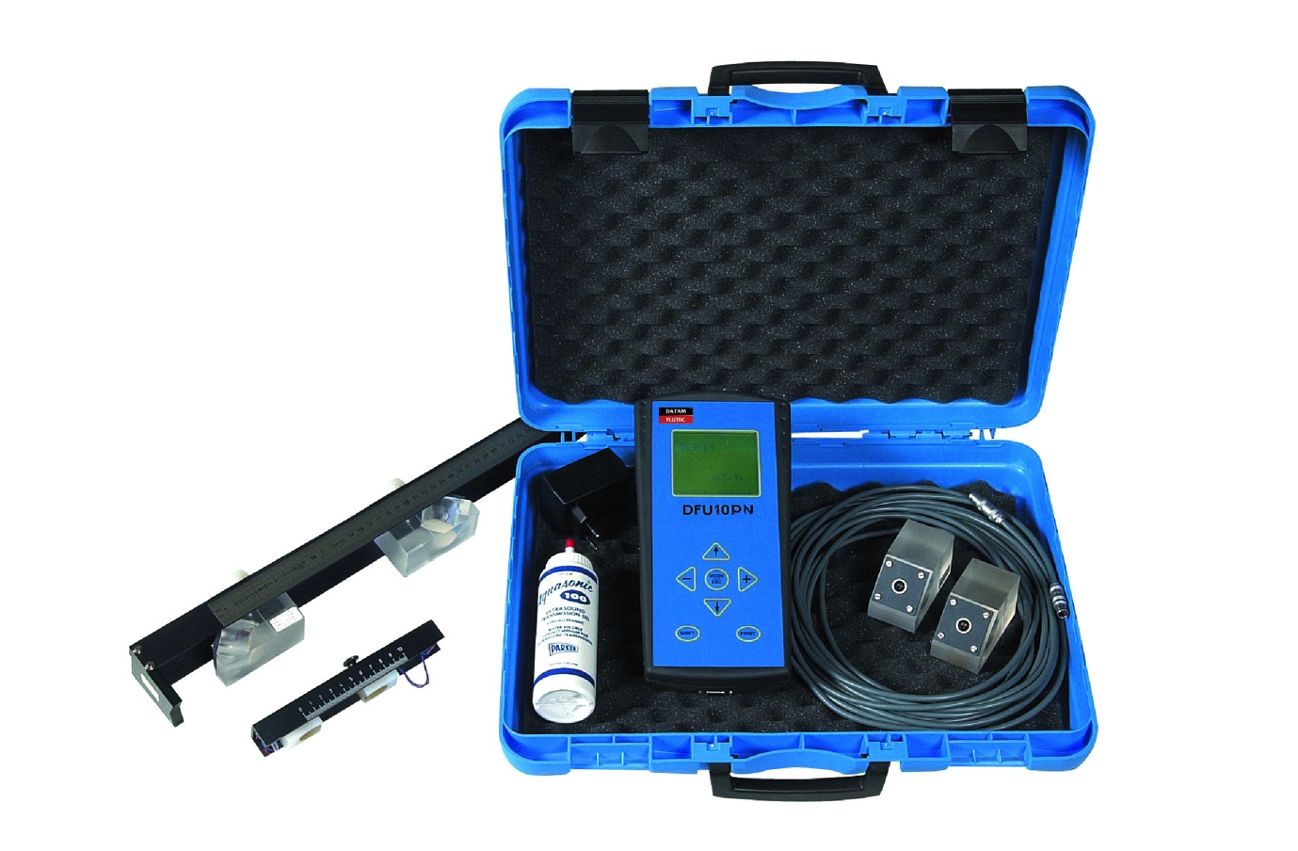

The FLT10 PN is an **ultrasonic portable flowmeter** for measurement of **bi-directional flow in pressurized (full) pipes** from ND 25mm up to 2000 mm.

It provides **high accurate measures** without any insertion (tapping or drilling) by using external clamp on probes set (range from 2Mhz to 500Khz depending on size and pipes material)

- Digital signal processing microprocessor

- Easy to configurate and use on field.

- Internal Logger storage up to 12 000 measures minimum

- Good value for money

# **FLT 10 Portable**

# Digital Ultrasonic FLOWMETER

**SPECIFICATIONS**

#### The ultrasonic portable flowmeter FLT 10 PN is a digital flowmeter that provides very accurate flow measurement in pressurized pipes from 25 up to 2000 mm diameters.

It works on all kind of homogeneous fluid even if not conductive.

Internal recording of flow rate and volume with totalizer (Std capacity : 12 000 data)

Technical Features

Polyamid Enclosure case IP 67

Graphic back-lighted LCD screen display

Dimension : 140X280X68 mm

weight 1,5 kg

Power supply : internal rechargeable battery

Autonomy :up to 10 hours continuous use

External charger 110 / 220 Vac 50 / 60 Hz /12 Vdc

External battery plug (12Vdc)

**Outputs** : Protected and galvanic

Current : 0 or 4-20 mA on 500 Ω

Pulse rate  configuration : 1 litre to 1000 m3

Pulse width : Adjustable from 100 to 1000m3

Flow direction switch relay (10 VA)

Relay for Alarm (if echo lost)

Graphic back-lighted LCD display

Flow in l/s l/h m3/s m3/h

Bidirectional flow and volume

2 Totalizers without reset + 1 totaliser with reset (direct way + 1 totaliser with reset (reverse way)

Com port RS 232 :115.200 bauds

Performances

Accuracy : better than 0.5%*

Linearity, Repeatability : 0,1 %

**External sensors**

Standard probes on mounted support for ND 10 to 80 mm - 2 MHZ

Standard probes on mounted support for ND 60 to 2 000 mm - 1MHZ

Special probes no mounted support for DN 100 to 2 000 mm 500 KHz

* measured on bench test